**Java Script Assignment**

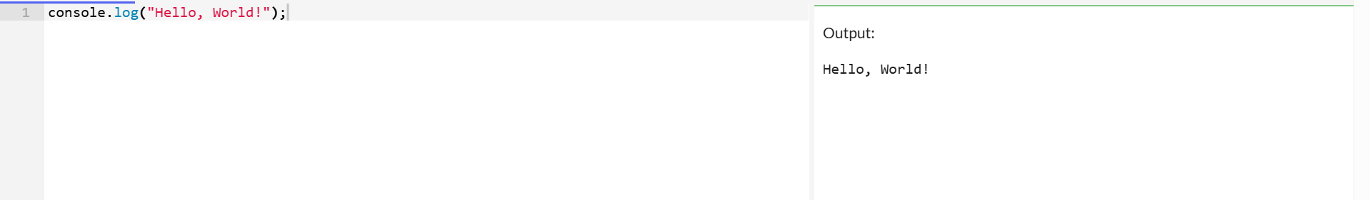

**On Client Side**

Using the document.write() method in JavaScript allows you to display “Hello World” on the client side HTML document.

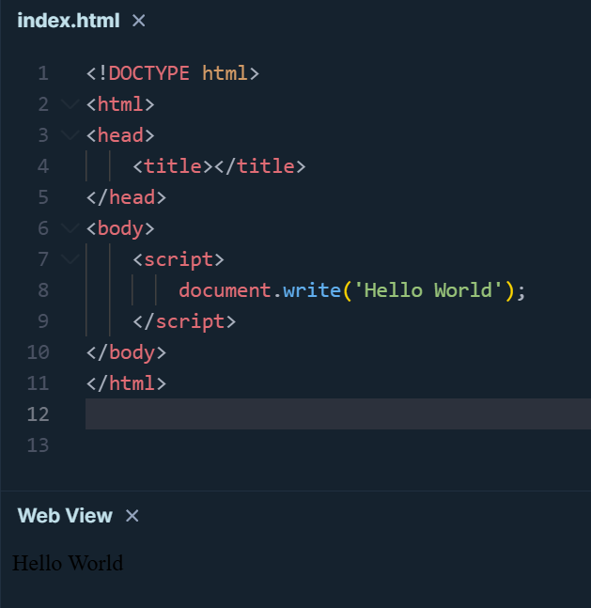

**Pop-Up on Client Side**

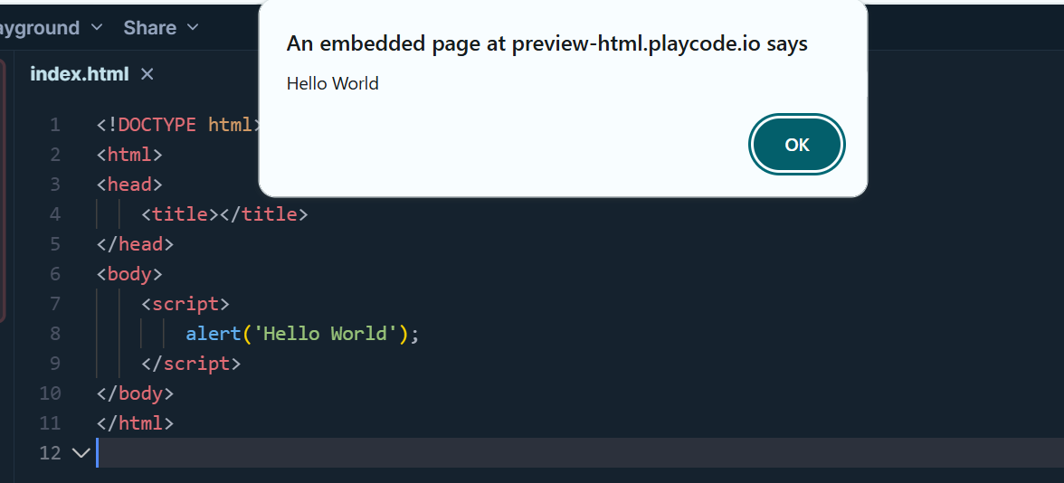

**Inline JavaScript**

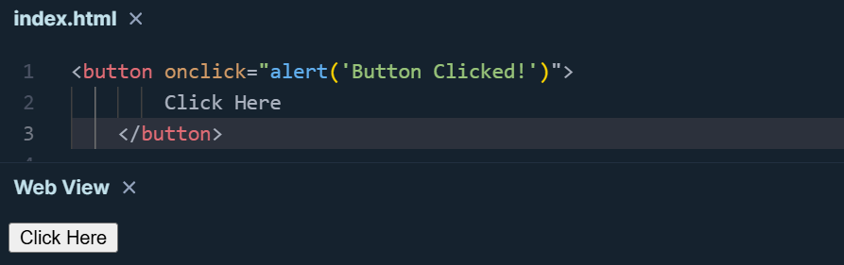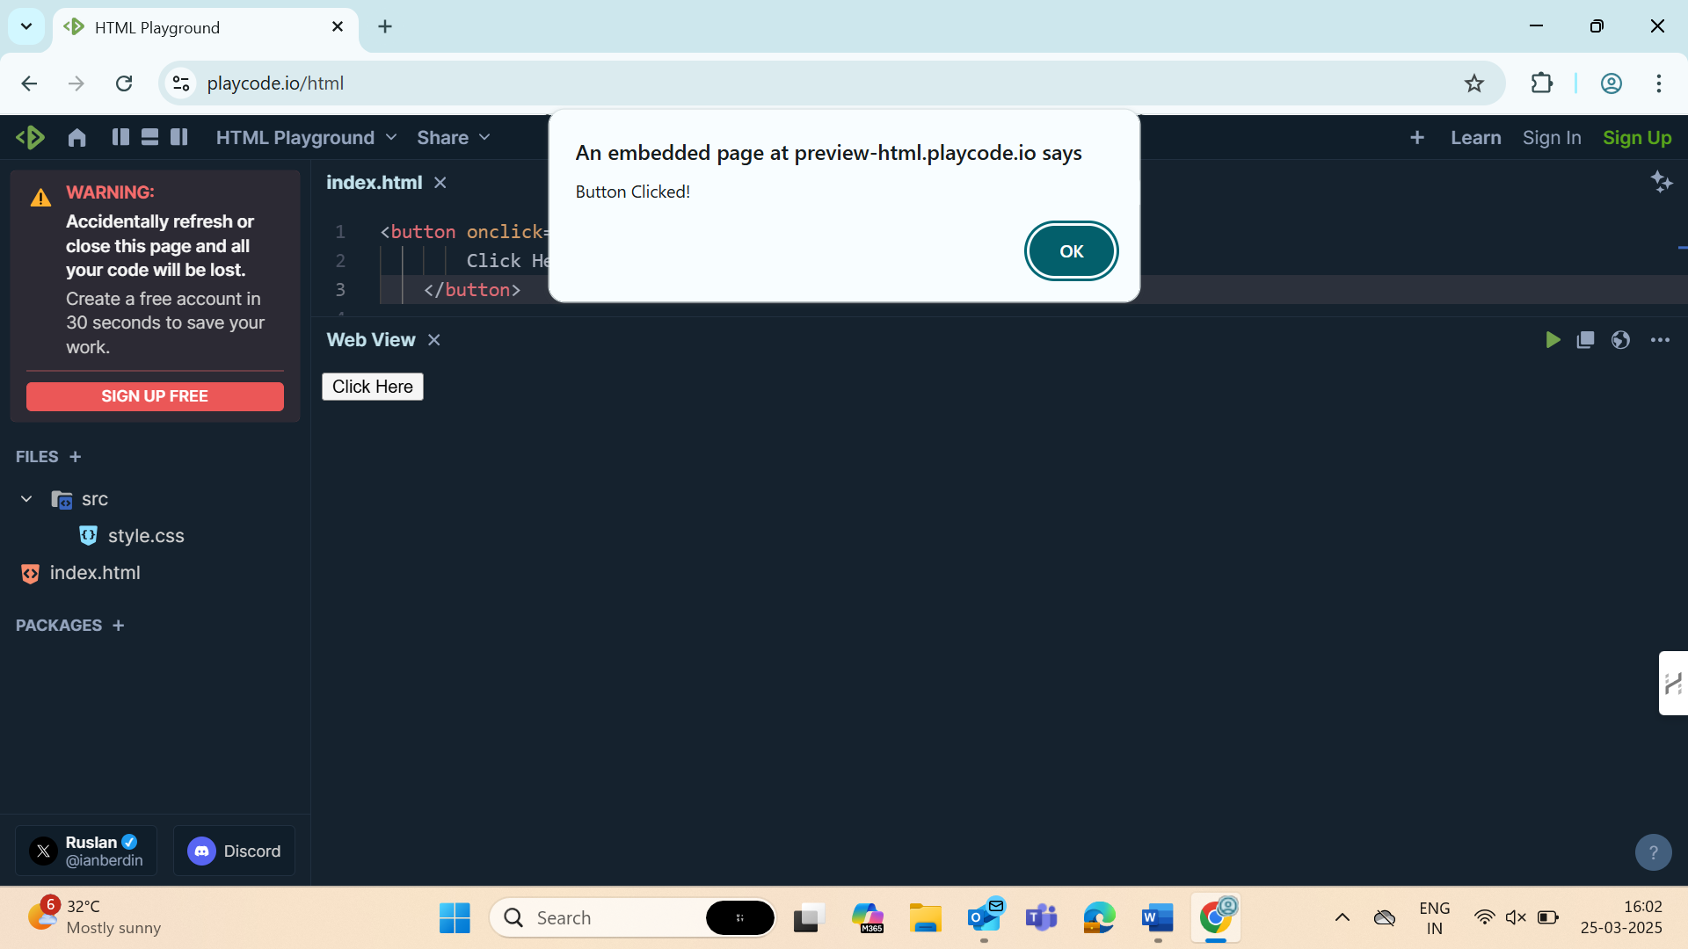

**JavaScript Code Inside <body> Tag**

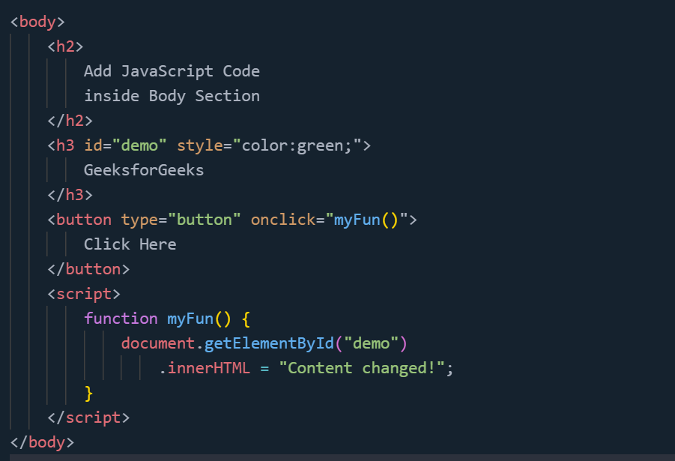



**Sum of two numbers using** **+ Operator**

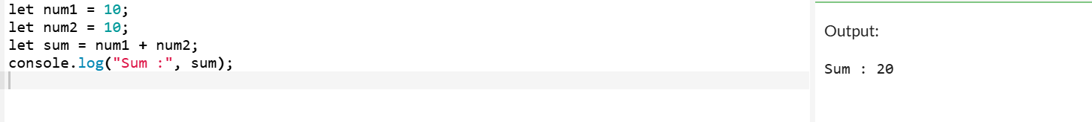

**Using function**

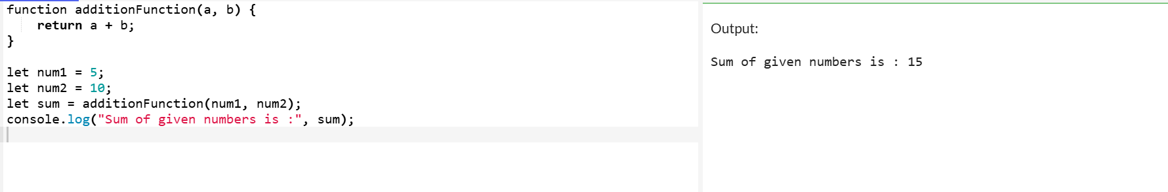**Using Arrow function**

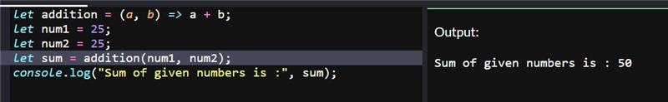

**Using Addition Assignment (+=) Operator**

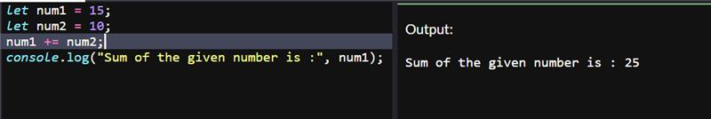

**3. Convert a regular function to an arrow function.**

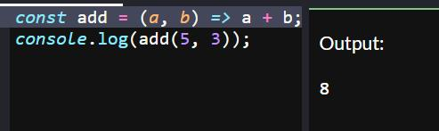

**1. Arrow Function without Parameters**

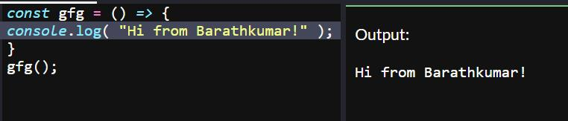

**2. Arrow Function with Single Parameters**

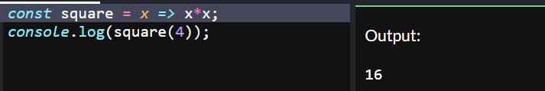

**3. Arrow Function with Multiple Parameters**

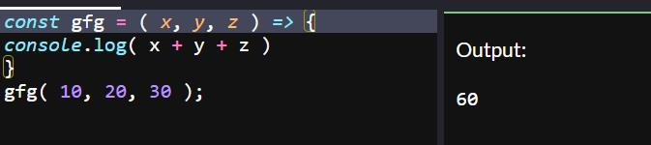

**4. Arrow Function with Default Parameters**

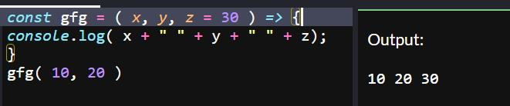

**5. Return Object Literals**

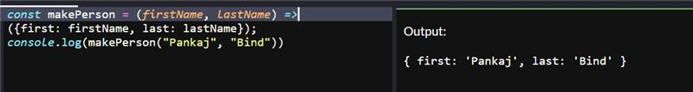

**4. Create a counter function using closures.**

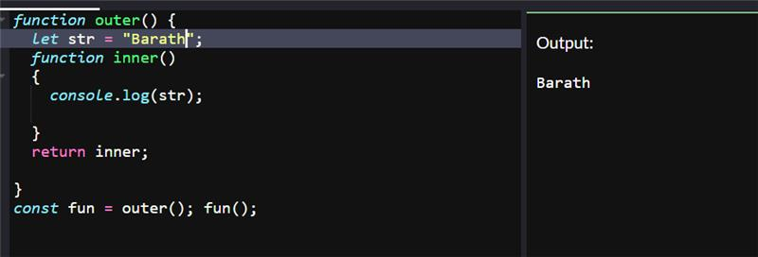

1. **Create a counter function using closures.**

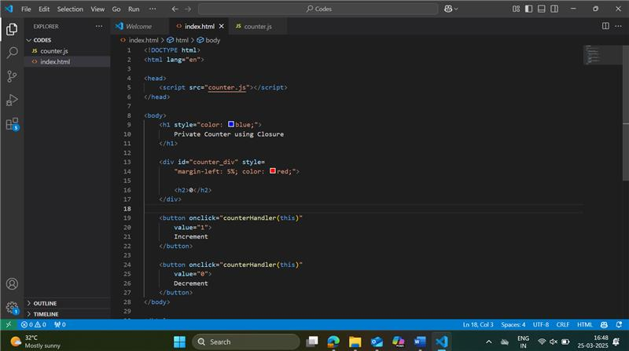

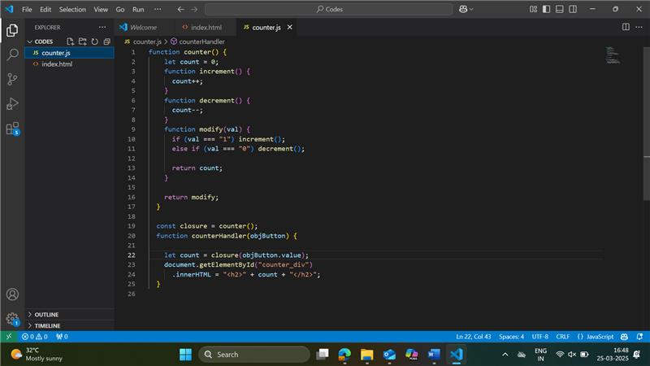

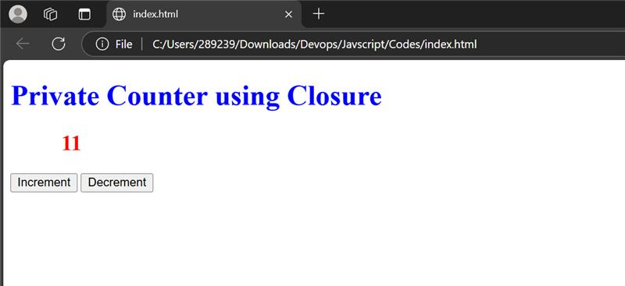

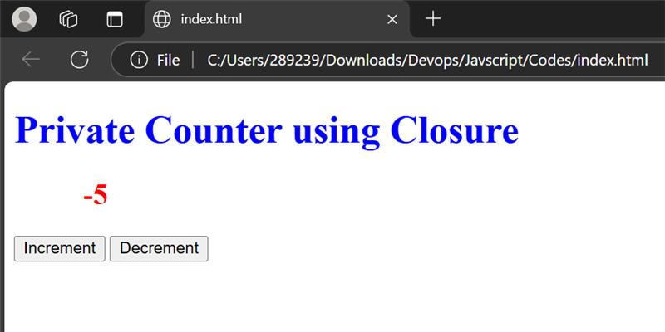

**Define an object representing a car with properties and a method.**

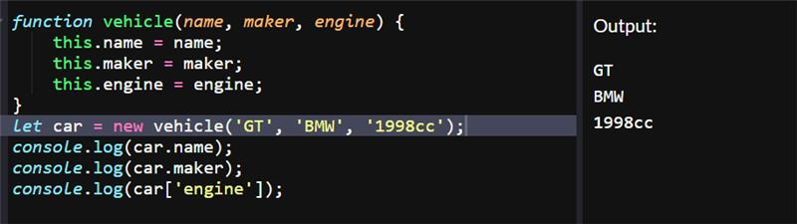

**Using object literals**

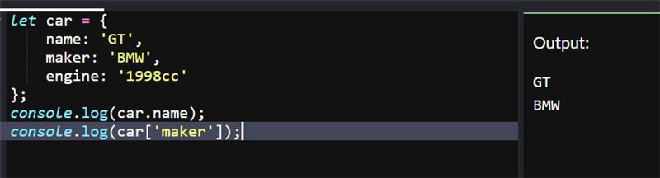

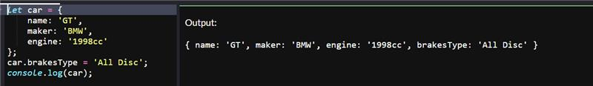

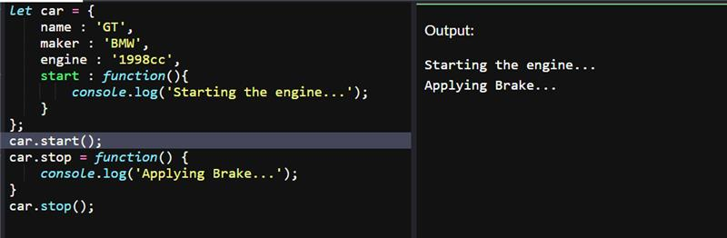

**Creating object with Object.create() Method**

